EMBEDDED SYSTEMS-ECA1401
EXP_2: Generation of Square Wave using Proteus
CIRCUIT DIAGRAM:
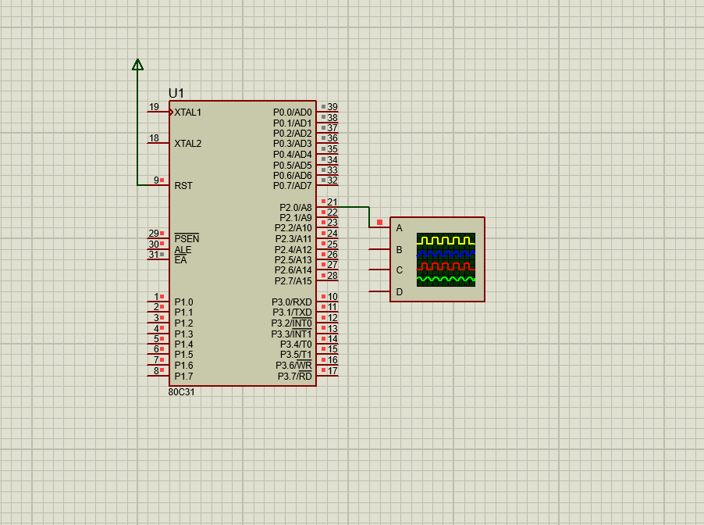
OUTPUT:
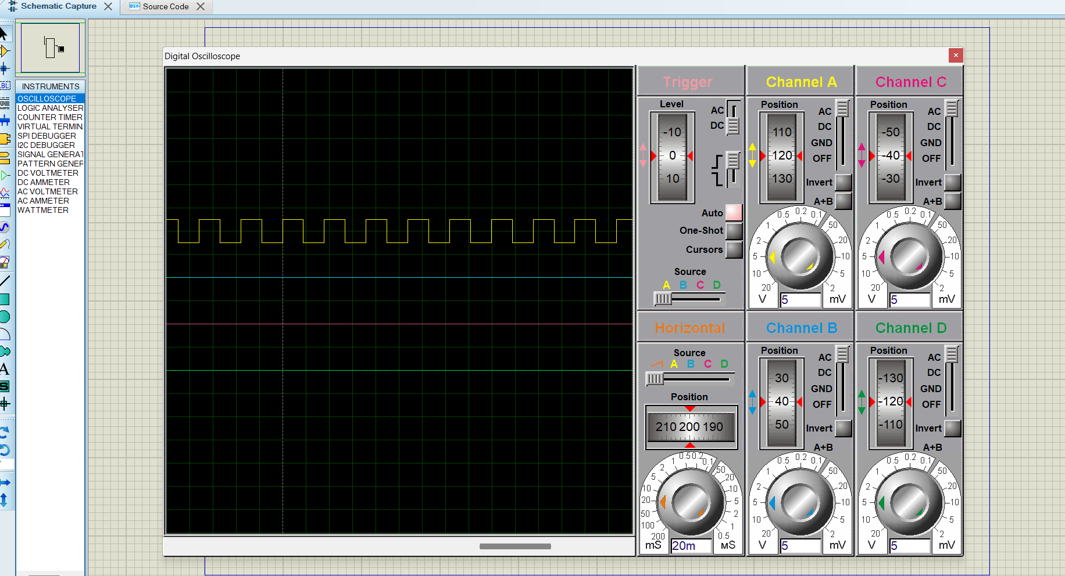
SOURCE CODE:
